Central province

* Camping

Haritha kanda

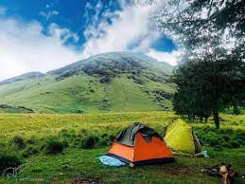

Haritha Kanda is in central province. Its a rocky mountain between Agarapathana and Bopaththalawa plains.its standing tall at about 1800m. Surrounding here is much similar to the Horton plains area since most of here is covered by montage grassland. Its a best hiking I ever had coz that was an amazing footslog for nature lovers.

* **Route**: Colombo -> Kottawa -> Avissawella -> Kithulgala ->Ginigathhena -> **Bogawanthalawa**

when you are just passing bogawanthalawa town look for a sign board stating “bogawana estate” to your left.since the road condition is pretty bad low profile vehicles wouldn’t be able to access on this.if you are doing this hike for day trip you can leave the vehicle on the road side

* **Transport :**Train / Bike / Taxi / Public Transport
* **Travel Time:** 1 Night 2 days Camping tour
* **Accommodation:**Camping tent
* **Activities:**  
  * Hiking  
  * Scenery  
  * Bathing in a natural pool  
  * Photography  
  * Camping at **Haritha kanda**

Yt-

<https://www.youtube.com/watch?v=q1zgGjsynw0&t=1063s&ab_channel=DineshAPathum>

<https://www.youtube.com/watch?v=sCJrBSZYvM&ab_channel=TheSailor>

Knuckles five peaks

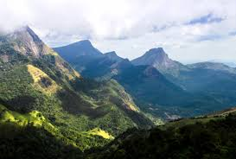

Knuckles mountain range consists of five peaks (as it looks like knuckles of the fist, called like that). There are about 36 prominent peaks in Knuckles massif and this is the 2nd highest peak out of them.  
There are two routes to start the trail. One from Bambarella side and other from Thangappuwa side. These two pathways join just below 1st peak. Both Bambarella and Thangappuwa can be approached by public transport.  
Few things to be kept in mind in this trekking; Bring enough water as no water sources after some distance, protection from leeches and unpredictable weather.  
Most of the time hikers go upto 2nd peak (highest point-1848m) and sometimes they camp at there.  
I had an experince of climbing all five peaks in one day without camping. In that case you have to start the journey in early morning with light pack.  
This is a moderate strenous hike it takes about 6 hours to reach the fifth peak from trail head- Bambarella side.  
There is a clear foot pathway till 2nd peak and trail can be easily traced after this. If you are new for this environment, better have a local guide.

Yt- <https://www.youtube.com/watch?v=O_sOZnGql_c&ab_channel=TravelHut>

* Hiking

Katusu Konda

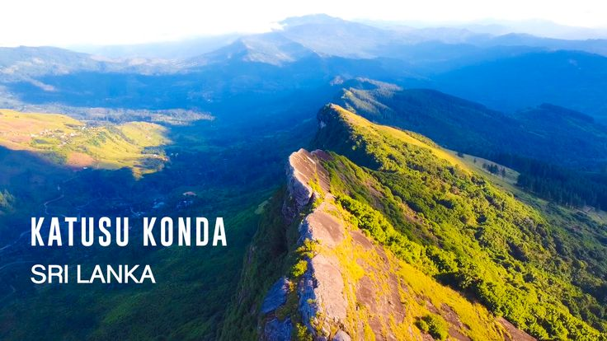

Katusu Konda is a peak found in the Hanthana Mountain Range in Kandy. It is named such due to its shape resembling the back of a lizard (Katussa). The path leading up to Katudu Konda is not very difficult to trek. However, it gets very windy at the top of the peak and the summit is also very narrow. The hike is an adventurous experience and looking down from the summit of Katusu Konda is a dangerously steep slope. Hikers can experience amazing views from the top of Katusu Konda which includes the Knuckles Mountain Range, University of Peradeniya, Kandy City, Monaragala, Alagalla and Hunnasgiriya.

Yt-

<https://www.youtube.com/watch?v=MbYnh0O5li0&t=4s&ab_channel=TheSailor>

<https://www.youtube.com/watch?v=8vo6K6naJ_Q&ab_channel=TripPisso>

Duvili Ella

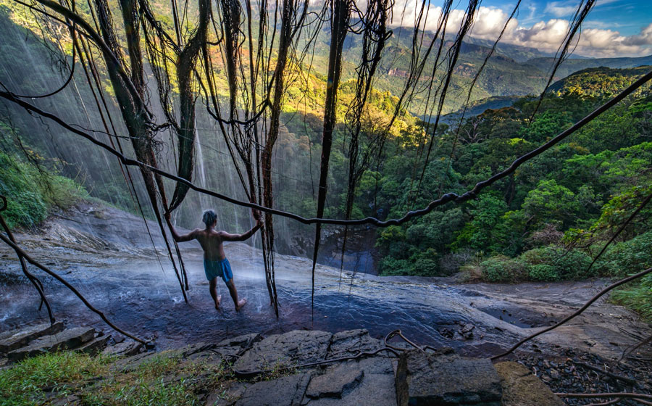

There are two main trails to for Duvili Ella hike. One Start From a Village Called Atanwala(7°30'53.5"N 80°45'30.1"E) and other start from a village called Rabukoluwa. Atanwala is close to famous Natural habitat Pitawala Pathana. Rabukoluwa(7°31'08.0"N 80°47'42.4"E) is close to Pallegema town. Both trails meets each other in the middle of the jungle and becomes one trail.

The journey itself is a amazing experience. You have to cross many beautiful creeks and Streams along the way. And there several of other little but beautiful waterfalls you would meet on the sides of the trail. Dumbara Ella is the biggest and most beautiful waterfall among those. It has some unique beauty you can’t find in anywhere else in Sri Lanka. One could keep looking at the flow less curtain of Dumbara Ella forever I guess. If you are going on a two night trip this would be the best stop for your first night.

Yt- <https://www.youtube.com/watch?v=FztEhxKvvLY&ab_channel=TravelBrothers>

* Road trip

Sigiriya

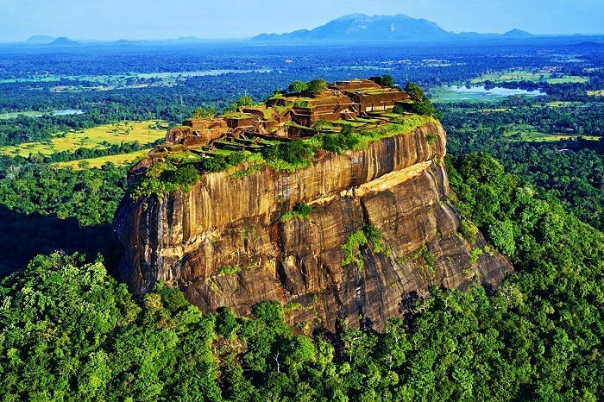

Sigiriya is one of the most valuable historical monuments of Sri Lanka. Referred by locals as the Eighth Wonder of the World this ancient palace and fortress complex has significant archaeological importance and attracts thousands of tourists every year. It is probably the most visited tourist destination of Sri Lanka.The palace is located in the heart of the island between the towns of Dambulla and Habarane on a massive rocky plateau 370 meters above the sea level.Sigiriya rock plateau, formed from magma of an extinct volcano, is 200 meters higher than the surrounding jungles. Its view astonishes the visitors with the unique harmony between the nature and human imagination.

The fortress complex includes remnants of a ruined palace, surrounded by an extensive network of fortifications, vast gardens, ponds, canals, alleys and fountains.The surrounding territories of Sigiriya were inhibited for several thousand years. Since 3th century BC the rocky plateau of Sigiriya served as a monastery. In the second half of the 5th century king Kasyapa decided to construct a royal residence here.After his death Sigiriya again became a Buddhist monastery until the 14th century, when it was abandoned.The main entrance is located in the northern side of the rock. It was designed in the form of a huge stone lion, whose feet have survived up to today but the upper parts of the body were destroyed.Thanks to this lion the palace was named Sigiriya. The term Sigiriya originates from the word Sihagri, i.e. Lion Rock.

The western wall of Sigiriya was almost entirely covered by frescoes, created during the reign of Kasyapa. Eighteen frescoes have survived to this day.The frescoes are depicting nude females and are considered to be either the portraits of Kasyapa’s wives and concubines or priestess performing religious rituals. Despite the unknown identity of the females depicted in the frescoes, these unique ancient paintings are celebrating female beauty and have incredible historical significance.One of the most striking features of Sigiriya is its Mirror wall. In the old days it was polished so thoroughly that the king could see his reflection in it. The Mirror wall is painted with inscriptions and poems written by the visitors of Sigiriya.The most ancient inscriptions are dated from the 8th century. These inscriptions are proving that Sigiriya was a tourist destination more than a thousand years ago. Today, painting on the wall is strictly prohibited.

Yt- <https://www.youtube.com/watch?v=LJwtJxnGacA&ab_channel=TripPisso>

[https://www.youtube.com/watch?v=pyNJ_spwPQ&ab_channel=vagabrothers](https://www.youtube.com/watch?v=-pyNJ_spwPQ&ab_channel=vagabrothers)

reverston

Located approximately 30 km from the Matale town, when travelling on Matale – Girandurukotte road, rather windy with quite a few hairpins turns but in good condition, offers great views all around with a mini worlds end, lot less travelled by main stream tourists. Climatic conditions here are very similar to Horton plains with the addition of having two great waterfalls “Sera Ella” and “Bambarakiri Ella”, both of which are a site for sore eyes, don’t forget to relax on the rock seats of “Sera Ella” relishing the cold misty spray of water on your face and Thelgamu Oya offers a great site for a dip in crystal clear but chilly water.

Travelling further upstream on this very scenic stream will no doubt will make you feel refreshed and rejuvenated. We recommend that you plan a trekking trip (02.5km) to the mist clad Riverston peak via pittawala pathana, as it offers some of the greatest views of the central hills across the mini worlds end which ends in a sheer drop of 300 meters offering a great vista especially of the “Knuckles range”, and the thelgamu valley below with its terraced paddy field method unique to the central hills of Sri Lanka.

Yt- <https://www.youtube.com/watch?v=t6iqgsn01Uk&ab_channel=ManSaranna%E0%B6%B8%E0%B6%82%E0%B7%83%E0%B6%BB%E0%B6%B1%E0%B7%8A%E0%B6%B1%E0%B7%8F>

Meemure

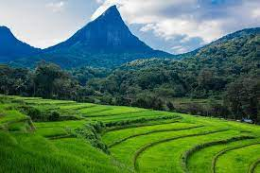

Meemure is an isolated village in the Central Province of Sri Lanka, located 324m above sea level and hidden amongst the mountains. The only way to reach it is from the  ‘Hunnasgiriya’ mountain, which is part of the Knuckles range, approximately 50km from Kandy. It’s a difficult trail of 33km from Hunnasgiriya to Meemure with many tricky spots, though the view along it is excellent. The village itself receives abundant water in the form of waterfalls that have their sources in the evergreen forests of the Knuckles. East of the village lies the pyramid shaped Lakegala mountain; while the west is dominated by the picturesque Knuckles range. The northern boundary of Meemure borders a forest which runs to the ‘Pitawala Pathana’ grassland; and the south is bounded by Heen River.

Pack-bulls used to be the solitary method of transport to Meemure until 2004. Herds of cattle carried sacks full of goods and equipment to the village. Due to the fertility and prosperity of the village; the pack-bulls were only used to carry salt, cloths, tobacco and calcium bicarbonate. But with the invasion of modern technology, the trails have been widened to allow three wheelers, jeeps and small trucks.

Yt- <https://www.youtube.com/watch?v=6HeG-h7GmpA&t=575s&ab_channel=TripPisso>

<https://www.youtube.com/watch?v=YGrqvW5jFfw&ab_channel=DalePhilip>

western province

* Camping
* Hiking
* Road trip

Browns beach

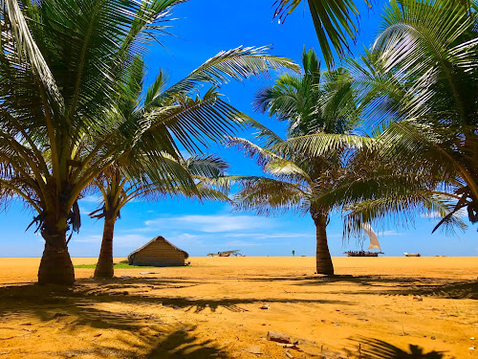

Browns Beach is one of the popular beaches in Negombo that is famous among the tourists as well as the locals. It is one of the few unspoiled private beaches in Negombo. Browns Beach is famous for its luscious golden sands, turquoise blue water and gorgeous palm trees. The beach is very close to the fishing village of Negombo and boasts of being the most popular seaside resort in Negombo.

Yt- <https://www.youtube.com/watch?v=cxkxrylJUVY&ab_channel=WalkWithMe>

Seethawaka botanical garden

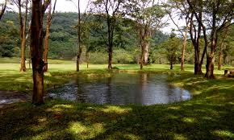

Seethawaka (Sitawaka) Wet Zone Botanical Gardens was opened in 2014 covering 106 acres ( 43 hectares) with the primary purpose of serving as a research area and a conservation area for threatened and vulnerable endemic plant species in the Sinharaja Rain Forest region. Improving export floriculture, ex-situ conservation of wet lowland plants, and bamboo cultivation are also promoted in this garden.The land used by this garden was established in 20th century as a plantation for Rubber and Tea, which was  known as “Pannagula”. But most of the land area was abandoned with time, which was taken over by Land Renew Commission. The construction of the Botanical garden on this reclaimed land commenced on 2008.

There is a food outlet in the garden but you can take your food inside. Generally vehicles can be taken inside but generally vans are not allowed in in most botanical gardens. If you wish you can hire a electric golf cart from the entrance.The lower part of the garden is maintained similar to a botanical garden with beautifully arranged flower patches, perfectly cut grass, and well maintained lake, where one can go for a boat ride. Further up, there is a high platform where you could have a grand view of the garden below and the mountainous surrounding. If you like bird watching, its recommended to go there early on weekday where there will be less crowd.

Yt-

<https://www.youtube.com/watch?v=qR_OcAFwPyA&ab_channel=Picture.lk>

<https://www.youtube.com/watch?v=wYydWbBNc14&ab_channel=USHANBro>

southern province

* Camping

Ussangoda

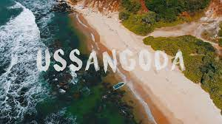

Ussangoda is a place of natural beauty and a designated archaeological site, situated near Ambalantota – Nonagama Junction in Hambantota District of Sri Lanka. It is also a nature reserve and is located in the southern turtle breeding zones. Ussangoda is a patch of high ground by the sea and spreads over a significant area. But unlike the rest of the land surrounding, it is only covered with grass and a few pockets of pigmy forests. The summit of Ussangoda area pans like a plateau for a significant length.

Ussangoda is known for its unusual placement by soil structure, biodiversity zone, and location. There are many folk stories related to this site which include different takes about the land. The general belief is that it is a part of a meteor or a proximity to a meteor hit. The main rationale for this belief is the soils brick-like hard quality with a reddish color which is unique to this patch of land. The soil has a high concentration of minerals/metals giving its unique color. It is evident that the Ussangoda earth is rich in minerals like Nickel. Some ingredients of the soil could attract magnets. In several places, especially by the sea facing areas rocks and soil can be observed clearly having multiple layers usually with distinct colorization. It is, however, unclear whether these speculations have been tested in any proper scientific study at all. It can be also noticed that Ussangoda is located geographically closer to another archaeological site “Miniha Gal Kanda”, where evidence for pre-historic human existence has been found.

There are several legends related to Ussangoda area. The history of this area dates back to the Rama-Ravana era. People believe that Ussangoda is the place where King Ravana’s airport was constructed and his big peacock shaped aircraft landed (Dandumonara). Another belief is that Ussangoda is the resting place of Demigod- ‘Mangara’. Another amazing feature is that the Ussangaoda was a dwelling site of the ancient prehistoric human in Sri Lanka

Yt-

<https://www.youtube.com/watch?v=x3MVn9wfyMo&ab_channel=TheSailor>

<https://www.youtube.com/watch?v=KRnn6IfielU&ab_channel=ConexTraveler>

Benthota

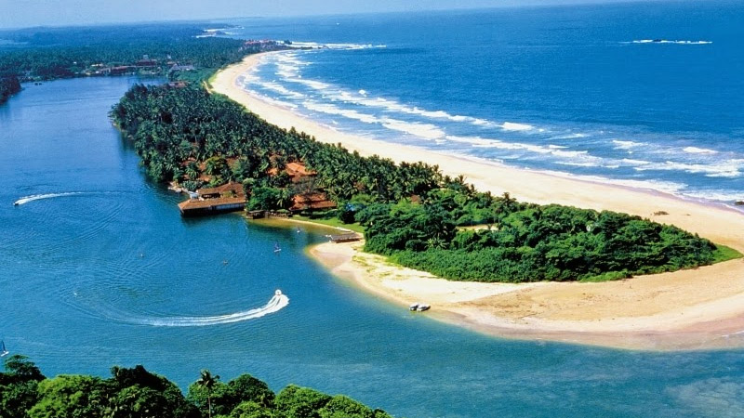

Bentota, a mere 45 minutes away from Colombo along the Southern express way, hails as a premier resort town with no less than 15 Star class Hotels clustered together plus numerous other less than 10 rooms boutique style hotels with Sun, surf and sand. This gives the visitor an ideal chance to stay in one and savour many different above water activities, Bentota has always been renowned as the water sport capital of Sri Lanka with the hoteliers in the area actively promoting water sports from adrenaline filled speed boat and jet ski riding, wind surfing, boogie boarding, water skiing, kite surfing, to a leisurely ride on a banana boat for the family & kids.

Yt- <https://www.youtube.com/watch?v=EPgu0MnlE2A&ab_channel=DiaryofRukaa>

* Hiking
* Road trip

Thangalle Beach

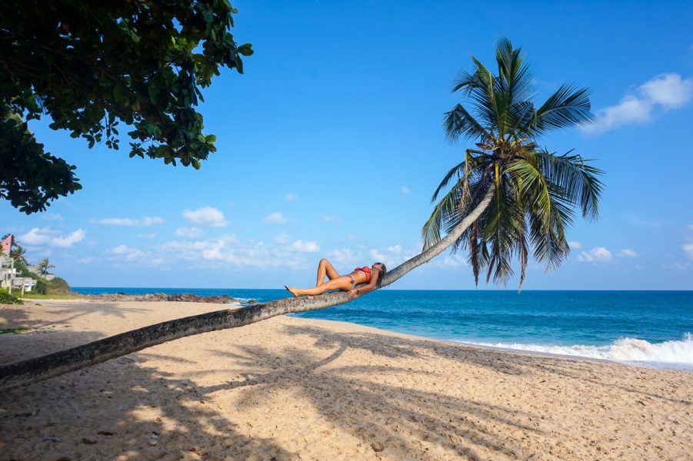

Tangalle Beach (also called Tangalla) encapsulates all that is alluring about this part of Sri Lanka: An unspoiled stretch of sand and a constant crash of waves make the area popular with both sunseekers and surfers. Take a break from the sun-worshipping and wander nearby among the secluded, rocky coves, the water frothing at your feet. Depending on the season, up to five different species of sea turtles can be seen visiting the shore to lay eggs.

Yt- <https://www.youtube.com/watch?v=OGY3GCj7TgQ&ab_channel=HugoAlexander>

Polhena beach

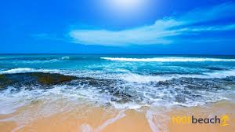

Located not far from the city centre of Matara, the Polhena Beach offers the perfect atmosphere for a beach getaway, without the crowds of tourists, making it all the more exclusive to anyone who visits the sandy stretch. The beach is primarily known to be a place of solitude and peace, so as to induce that sense of calmness in the minds of the traveller. Even the waters are relatively calmer than that experienced in Galle and Weligama, because of the corals acting as a fence of sorts. Although popular as a picnic beach, there are a few water sports that you can engage in, namely swimming and snorkelling.

There are other interesting elements of the Polhena Beach such as the Nilwala River, which runs through the entire city of Matara, eventually falling into the sea through Polhena Beach, which makes it quite a majestic sight. It is, however, when the sun starts to set that the true beauty of the beach is shown, as it turns out to be the perfect place to admire the palm-fringed beauty of Sri Lanka’s coastal belt. There are several vantage points to view the amazing scenery, but it’s often the area near the Nilwala River that provides the best vistas.

Yt- <https://www.youtube.com/watch?v=Rd8KwQ0NzDw&ab_channel=TravelWithChatura>

sabaragamuwa province

* Camping
* Hiking
* Road trip

uva province

* Camping
* Hiking
* Road trip

Eastern province

* Camping

Arugambay Beach

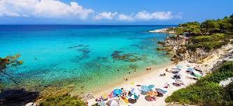

**Arugam Bay** ([Tamil](https://en.wikipedia.org/wiki/Tamil_language): அறுகம் குடா), known locally as "Arugam Kudah", is situated on the [Indian Ocean](https://en.wikipedia.org/wiki/Indian_Ocean) in the dry zone of [Sri Lanka](https://en.wikipedia.org/wiki/Sri_Lanka)'s southeast coast, and a historic settlement of the ancient [Batticaloa Territory](https://en.wikipedia.org/wiki/Batticaloa_Territory) (Mattakallappu Desam). The bay is located 117 kilometres (73 mi) south of [Batticaloa](https://en.wikipedia.org/wiki/Batticaloa), 320 kilometres (200 mi) due east of [Colombo](https://en.wikipedia.org/wiki/Colombo), and approximately 4 kilometres (2.5 mi) south of the market town of [Pottuvil](https://en.wikipedia.org/wiki/Pottuvil" \o "Pottuvil). The main settlement in the area, known locally as Ullae, is predominantly [Muslim](https://en.wikipedia.org/wiki/Muslim),[[1]](https://en.wikipedia.org/wiki/Arugam_Bay#cite_note-1) however there is a significant [Sri Lankan Tamil](https://en.wikipedia.org/wiki/Sri_Lankan_Tamil_people) and [Sinhala](https://en.wikipedia.org/wiki/Sinhalese_people) population to the south of the village, as well as a number of international expatriates, largely from Europe and Australia. While traditionally fishing has dominated the local economy, tourism has grown rapidly in the area in recent years. Arugam Kudah's literal Tamil translation is "Bay of [Cynodon dactylon](https://en.wikipedia.org/wiki/Cynodon_dactylon" \o "Cynodon dactylon)". Tourism in Arugam Bay is dominated by surf tourism, thanks to several quality breaks in the area, however tourists are also attracted by the local beaches, lagoons, historic temples and the nearby [Kumana National Park](https://en.wikipedia.org/wiki/Kumana_National_Park" \o "Kumana National Park).

Yt- <https://www.youtube.com/watch?v=WCjRuntfGbc&t=45s&ab_channel=DineshAPathum>

* Hiking
* Road trip

Northcentral province

* Camping

Nuwaragala

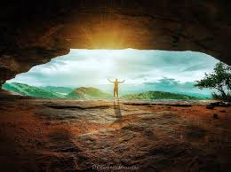

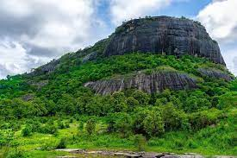

Nuwaragala Kanda belongs to the Maha Oya Divisional Secretariat in the Ampara District of the Eastern Province. Nuwaragala is geographically important as a remnant mountain (more than 300 meters high after erosion) belonging to the Gal Oya mountain range, which is located in half the plains of Sri Lanka (region between 30-300 m above sea level). The height is 658 meters.

**Route:** Mahiyanganaya --> Padiyathalawa --> Mahaoya --> Flying Village (Kandy-Ampara Road). From there you have to walk about 04 km to the foothills. A tractor can be used for this. You have to climb another 2-3 km from the foot of the mountain.

* Hiking
* Road trip

Northwestern province

* Camping

Baththalangunduwa

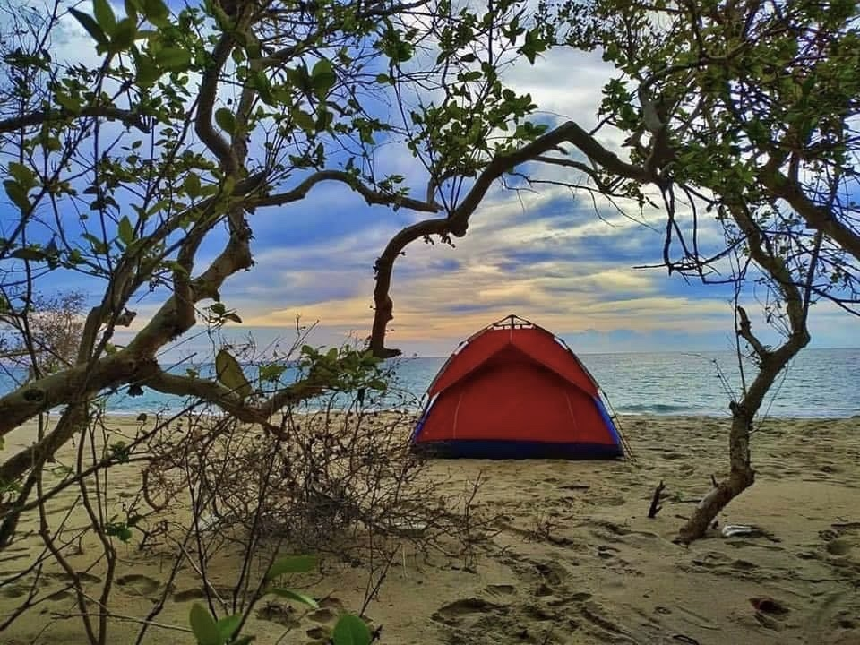

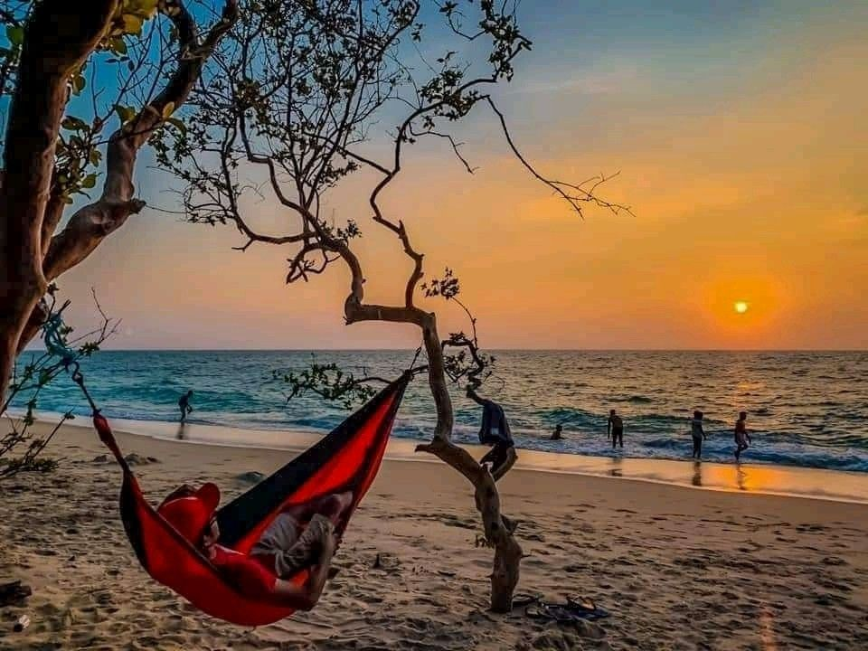

Baththalangunduwa Island is a small island off the coast of Kalpitiya in the Puttalam District of the North Western Province of Sri Lanka. There are 14 islands. Baththalangunduwa is the second-largest island after Uchchimune and Mohontuwara. Baththalangunduwa Island covers an area of 145.53 hectares. Baththalangunduwa has located about 30.3 km from the mainland.

 Baththalangunduwa Island is located about 25 nautical miles (30.3 km) from Kalpitiya. It takes about 3.5 hours to travel from Kalapitiya to Baththalangunduwa. You can take a boat ride from Kalpitiya to Baththalangunduwa Island with amazing views.

Two passenger boats ply to the island from the Kalpitiya jetty. The regular passenger ferry service starts daily at 8.30 am. About a three-hour drive. The fare per person is close to 250 rupees. There is also a comfortable passenger transport service with comfortable seating and safety. But for that, you have to reserve seats in advance.

Yt- <https://www.youtube.com/watch?v=DTStPqtHbac&t=119s&ab_channel=DineshAPathum>

<https://www.youtube.com/watch?v=VYDS_jXYP1k&t=6s&ab_channel=TripPisso>

* Hiking
* Road trip

Northern province

* Camping
* Hiking
* Road trip